  - NAT Platform Services
  - Test Automation Overview

Contents
Introduction 3
Tools and Frameworks 4
Frontend (Functional) 4
Frontend (Non-Functional) 4
Rest API Based Services 4
Performance 4
Design Continuous Testing Model 4
Types of Test Automation 5
Functional Automation Type - Overview 6
UI Responsiveness Automation Type – Overview 8
Performance Automation Type – Overview 11
Test Automation Architecture 14
Test Automation Work Flow 16
Test Automation Script Flow 19
Roadmap 20
Conclusion 21
Key Takeaways 21

Introduction

NAT Platform Services is a web based application developed using some cool and cutting edge technologies like React, AXON Server, Java, HTML5, Spring Boot and AWS.
QA team of Platform Services uses some equally cool and cutting edge technologies & frameworks to test and automate these services, backend and frontend.
This is an agile based development and follows Continuous Integration, Testing and Deployment. Hence, deployment, testing and release are fully automated processes.
Team has designed build, test and deployment systems which performs Continuous Integration, Continuous Testing and Continuous Deployment automatically.

Tools and Frameworks

QA Team of NAT Platform Services uses cutting edge technologies and framework to design and test the product.

To automate different Test Automation types, QA team have identified various tools and frameworks which is highly ranked and valued as per current market trends.

Frontend (Functional)
- Selenium
- Serenity with Screenplay
- Cucumber
- Java
- Gradle

Frontend (Non-Functional)
- Gallen
- Javascript
- Gallen Spec

Rest API Based Services
- Rest Assured
- Serenity with Screenplay
- Cucumber
- Java
- Gradle

Performance
- Taurus with Jmeter
- YAML

Design Continuous Testing Model
- Git Hub Actions
- Javascript
- NodeJS
- Docker
- AWS

Types of Test Automation

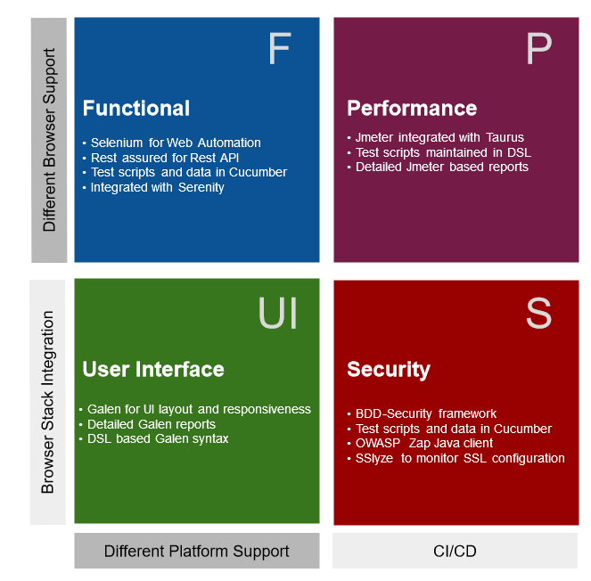

Functional Automation Type - Overview
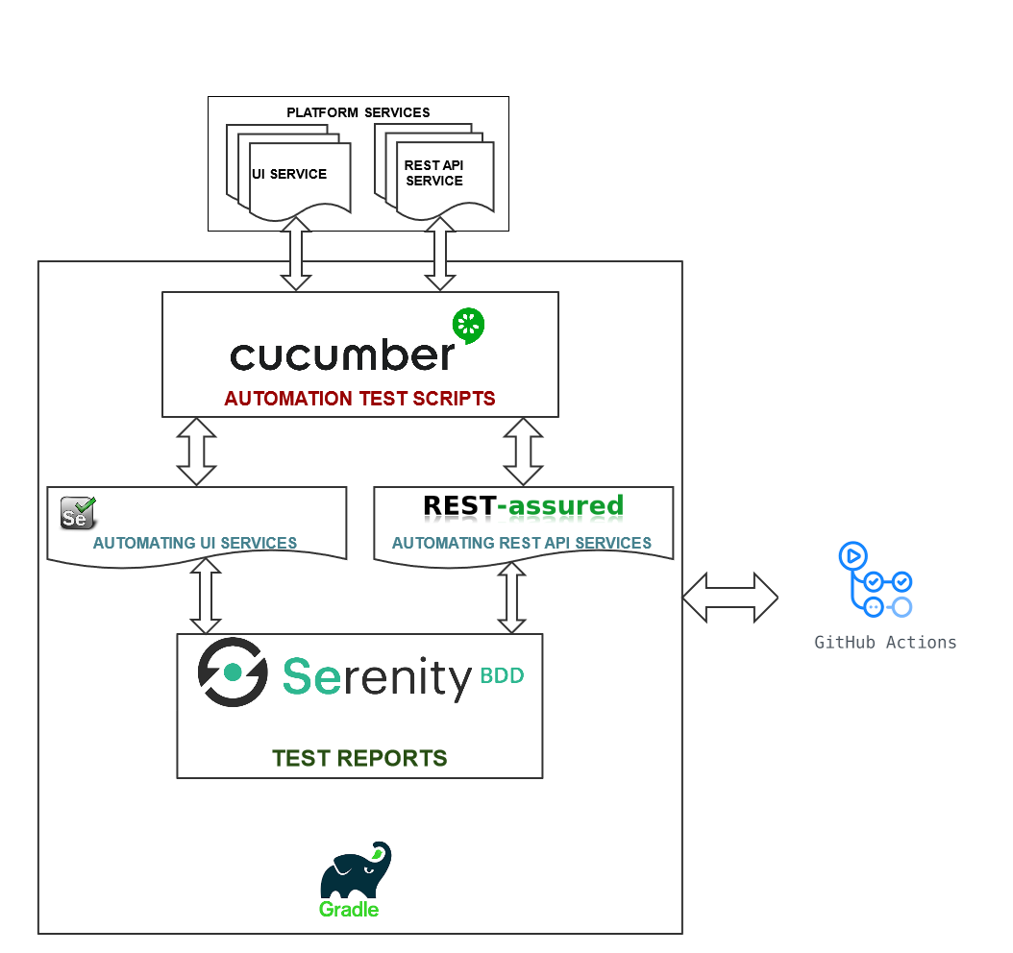

The above model displays explains the functional test automation high level architecture.

FUNCTIONAL TESTING is a type of software testing that validates the software system against the functional requirements/specifications. The purpose of Functional tests is to test each function of the software application, by providing appropriate input, verifying the output against the Functional requirements.

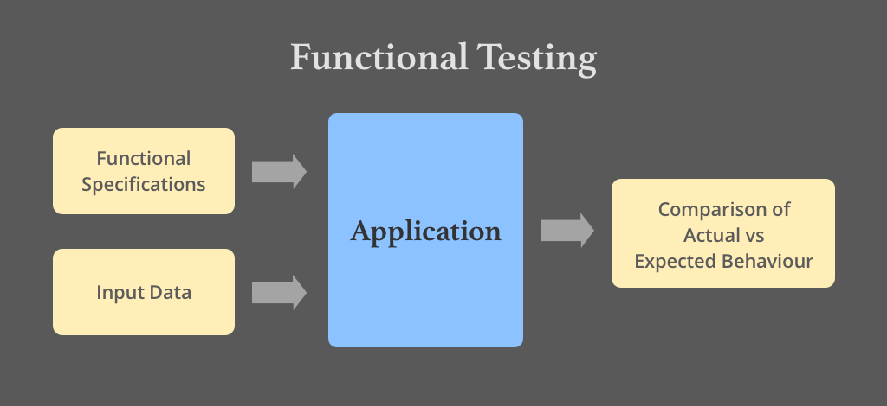

Now referring back to our original functional test automation architecture, under functional test we verify two major application types

- Web User Interface – Verification of dynamic/static functionalities implemented through the User Interface.
- Rest based Web API – These API act as an interface between backend and frontend. Here we basically verify the data received (provided by the backend through these API)

Functional test are written and maintained in Gerkin language, for which we are using a tool called Cucumber. As per Gerkin standards, each requirement is covered as a feature and every feature contains multiple scenarios and user data.

The steps defined in feature file is mapped with a java class, and this java class will refer the required objects (frontend elements) and libraries (front-end and rest api)

Serenity is as a BDD based test-automation framework which is used to test both frontend and Rest API. Serenity automatically collects the test data and creates a HTML based test-report.

Gradle is a driver which triggers these tests by calling a java based main() class.
The main() class initializes & executes the tests and creates the test-report.

As a part CI/CD initiative, GIT-HUB Action will automatically trigger these tests, collects the test-artifact and copies them on the AWS.

UI Responsiveness Automation Type – Overview

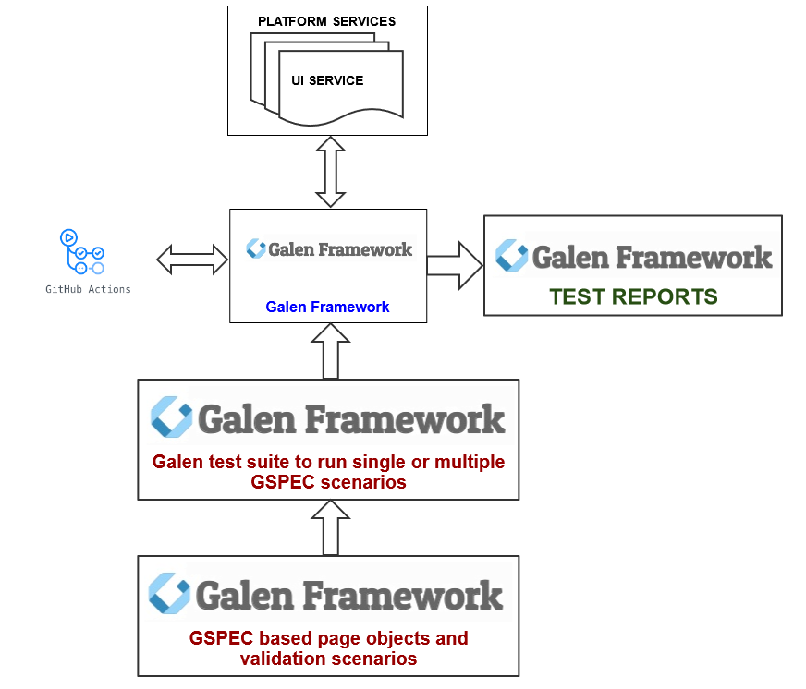

The Responsive design test means testing the website or URL from different devices. Practically, it is not possible to test the responsive website completely because to do so we need to set up various systems for various screen sizes.

To achieve the standard coverage of the devices, we have listed down the below list of devices.

Device Name | Type | Screen Size
iPad Mini | tablet | 768x1024
iPad Pro (10.5 inch) | tablet | 834x1112
iPad Pro (12.9 inch) | tablet | 1024x1366
Kindle Fire HDX | tablet | 800x1280
Apple MacBook Air 13-inch | laptop | 1440x900
Amazon Fire HD 10 | tablet | 1280x800
Apple MacBook Pro | laptop | 1280x950
Nexus 10 | tablet | 800x1280
Microsoft Lumia 550 | phone | 640x360
Acer Picasso | tablet | 768x1280
Amazon Fire | tablet | 1024x600
BlackBerry Porsche Design P9982 | tablet | 1280x768
BlackBerry Leap | tablet | 1280x720
Apple MacBook Air 11-inch | laptop | 1366x768
Dell Inspiron 14 series 36 inch | laptop | 1600x900
Apple MacBook Pro 15-inch | laptop | 1680x1050
Dell XPS 13 | laptop | 1920x1080

Referring to the above UI Responsiveness automation test architecture, Galen framework is used to execute the UI responsiveness tests automatically.

The UI Responsive tests are designed with below listed points in mind.
- Test For Navigation On Website
- Test Fonts On Multiple Devices
- Test On Device-Browser Combinations
- Test On different Screen Devices
- Test For Element Alignments
- Test For Content Placement
- Test For Cross Browser Compatibility Issues
- Test For Interactive Experience
- Test Website Popups Mobile-Friendliness
- Test The Website As A User

Galen has a DSL based language known as Galen Spec which is used to design the tests. Each test file is saved with an .gspec extension. These tests can be executed individually or can be grouped inside a test-suite file.

The test-suite also contains the list of browsers and Screen-sizes on which the tests have to be executed.

Below attached is a sample Galen test-suite file.

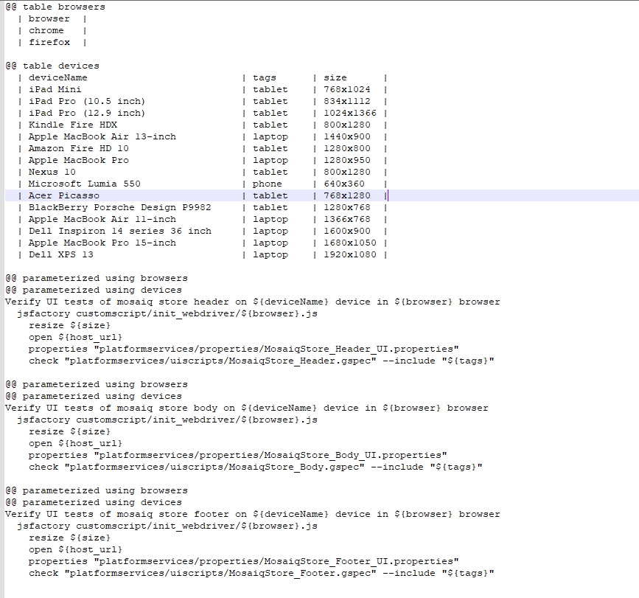
Galen framework creates HTML based test report which provides the detail analysis of the failed and passed scenarios.

Under CI/CD initiative, GIT-HUB Action will trigger the tests by executing Galen Test command.

Performance Automation Type – Overview
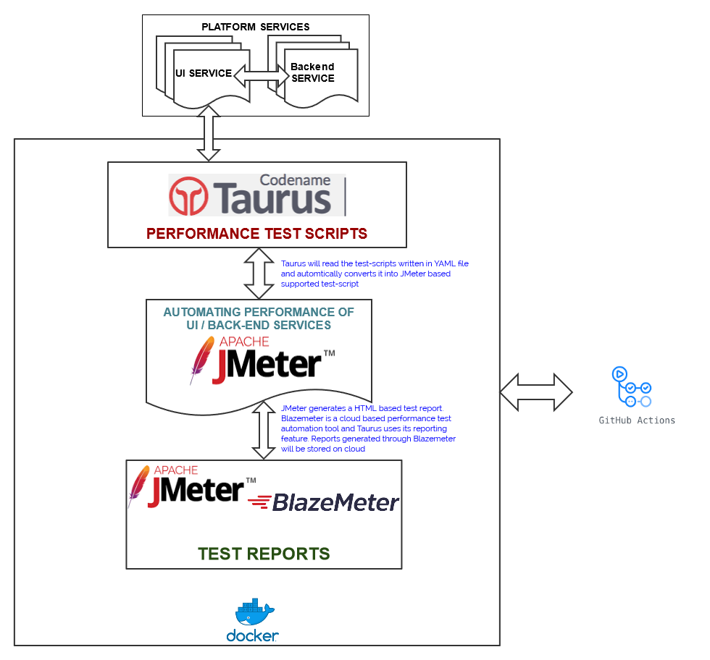

Performance testing is a testing measure that evaluates the speed, responsiveness and stability of a web-application under a workload. Organizations will run performance tests in order to identify performance-related bottlenecks.

The above Performance test architecture uses Taurus as a framework which internally uses JMeter to execute the performance tests.

The basic advantage of using Taurus is that the underlying tool can be changed without making any changes in the tests. The tests written is Taurus uses a DSL based language which is a universal language and do not require anyone to become an expertise of any particular tool.

- Taurus is an acronym that stands for Test Automation Running Smoothly.
- Taurus is a tool that provides a simple way to create and run performance tests.
- Provides an easy integration with additional open-source functional and performance testing software, like Selenium, Gatling or JMeter.
- An easily-readable, version control friendly and unified DSL (Domain-specific language) to define load test scenarios.
- The ability to create new tests from scratch using the aforementioned DSL.
- The ability to merge multiple existing test scripts and/or DSL-driven tests into a single scenario.
- The ability to execute existing JMeter (or Grinder or Gatling or Selenium) tests.
- Real-time reporting.
- Integration with the blazemeter.com reporting service.
- An easy way to define flexible pass/fail criteria. In case the results exceed a threshold, it is possible to automatically mark test(s) as failed.
- Platform-independency - runs where Python and Java can run.
- Extremely simple setup and upgrading

As per the above architecture, Taurus provides a docker image which is easily configurable as per user needs.
Each test is written in Taurus is stored in an YML format. Please refer the below attached example:

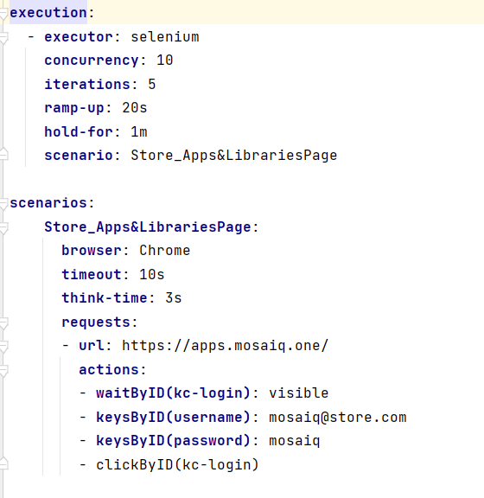
All the tests can be grouped inside a master YML file which acts as a test-suite file and contains additional configurations and settings.
Please refer the below attached test-suite file example:

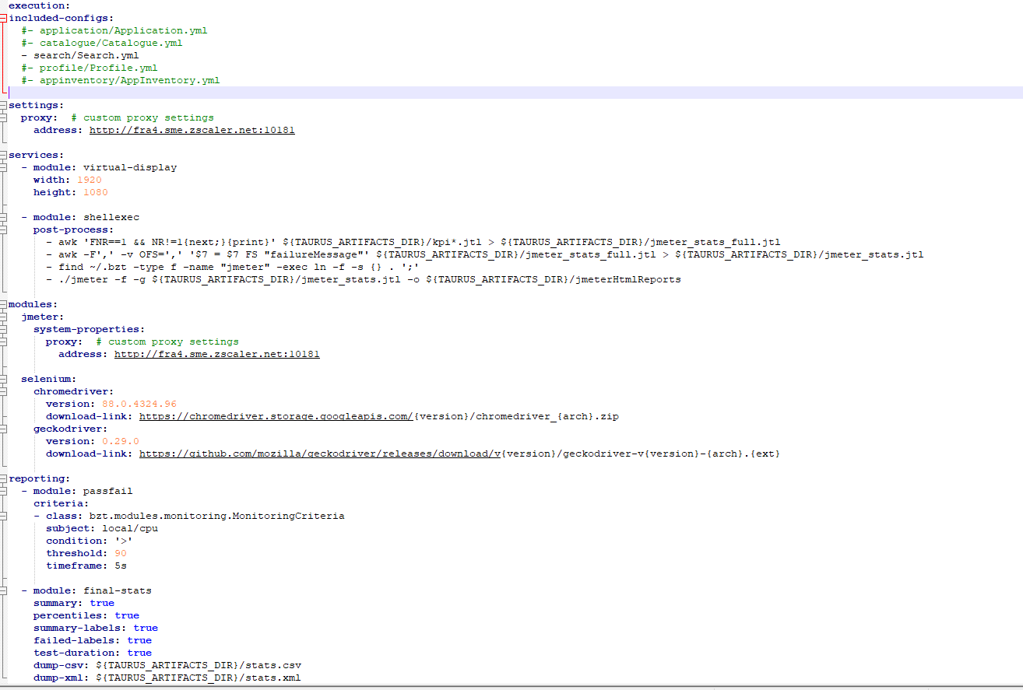
Git-hub Action will trigger a Taurus command to trigger the YML file which will execute all the referred tests and create a JMeter based HTML report. Additionally, user can connect with Blazemeter to create a cloud based Blazemeter report. The free account of Blazemeter allows user to keep the copy of the report for 7 days only.

Test Automation Architecture

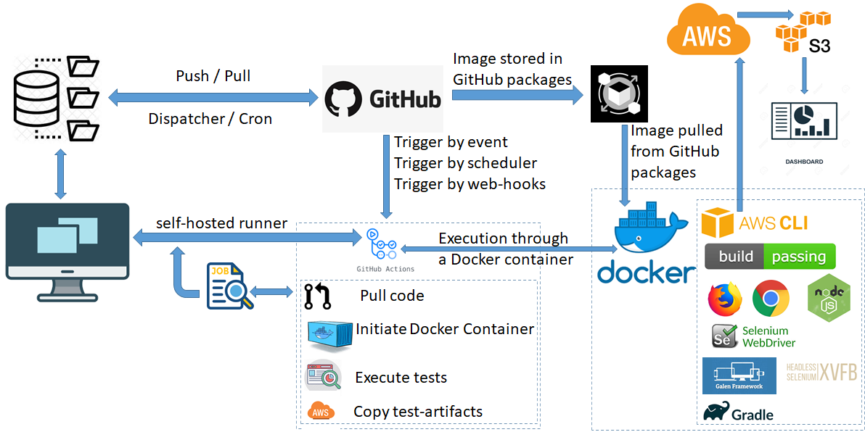

The above model explains the test automation architecture designed for Platform Services.

QA team maintains the test automation framework code and test scripts in repository maintained in GitHub.

GitHub also stores a test infrastructure docker image under GitHub package.

The docker image contains the required test environment (browsers, frameworks, libraries and build & test engine) to launch and perform automated testing.

The repository contains a workflow which is called by GitHub to trigger the set of actions defined under the workflow.

In case of Platform Services once the workflow is triggered:
- The latest code is triggered
- Docker Container is Initialized
- Tests are executed
- Test Artifacts generated during execution are copied to AWS

A test system needs to associated with a workflow which can be either a Virtual system hosted at GitHub / AWS or it can be a local hosted system connected with GitHub through Self-Hosted Runner.

Self-Hosted Runner is a GitHub Service which needs to be configured on the system required to be connected with GitHub. When the service is running on the system GitHub can identify the system and can perform the execution of the workflow on it.

Test Automation Work Flow

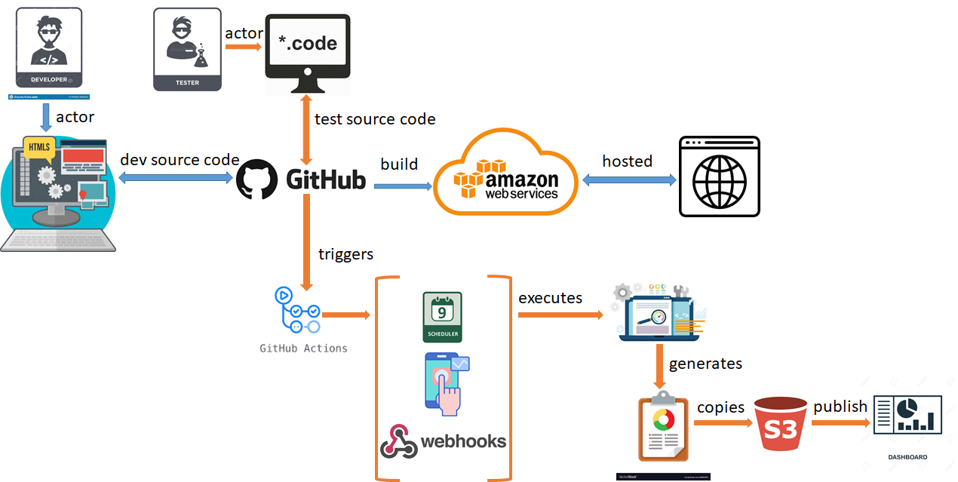

The above model explains the work flow of test automation when QA team develops and integrates the automated test-scripts with the framework.

Test Automation can be triggered by 3 ways:

- Manually: This is an on-demand approach where any member from QA / Developer can manually trigger the test-automation by clicking the <Run workflow> from the GitHub Actions.

- Scheduler: This is a scheduled approach where workflow will get triggered automatically at a scheduled day and time.

- Webhooks: This is also an on-demand approach but more in lines with Continuous Testing and Integration approach. Webhooks are customizable GitHub action rest API which user can integrate with its workflow to trigger an external workflow. This means a developer can integrate a Webhook in its workflow process. Once the code is developed, compiled, build and successfully deployed, the development workflow can trigger the test-automation workflow. If the tests are successful then code will get merged with Master branch else a defect will get raised and merging of code in Master branch will not happen.

Developer develops the code and merge it in the repository hosted at GitHub. This code gets compiled, build and deployed in AWS.

QA team develops the test-scripts and merge it in the repository hosted at GitHub. Same repository also maintains the Test Automation Framework code.

GitHub contains a tool known with a name GitHub action. This tool is used to automate the build, deploy and test processes. In order to automate a process through GitHub action, GitHub repository should be configured with a Workflow. Workflow defines Step and every Step is associated with some desired action.

A screenshot of an executed GitHub action workflow for reference has been provided. This will show you the execution flow of Steps with desired Actions designed inside the workflow.

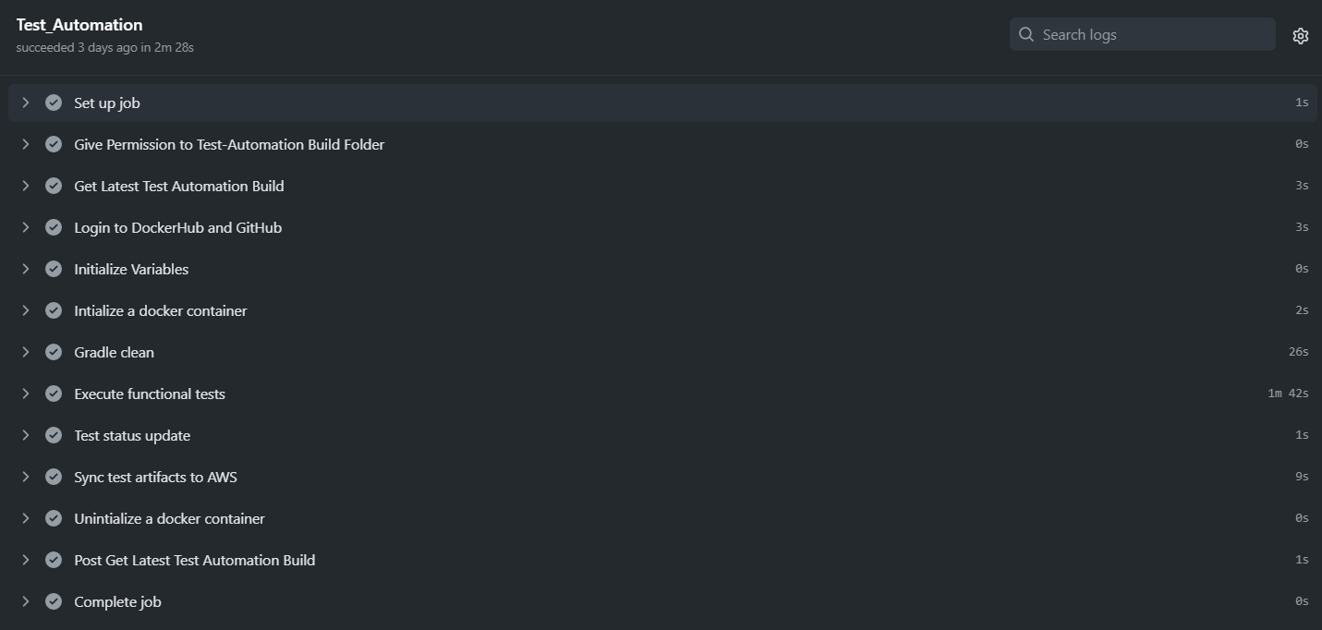

GitHub Action triggers the functional tests -> Generates the Test Artifacts -> Copies the Test Artifacts to AWS -> Publish the Test Data for Dashboard

A screenshot of Dashboard has been provided for reference. The Dashboard publish test data for all the NAT projects which also includes Platform Services.

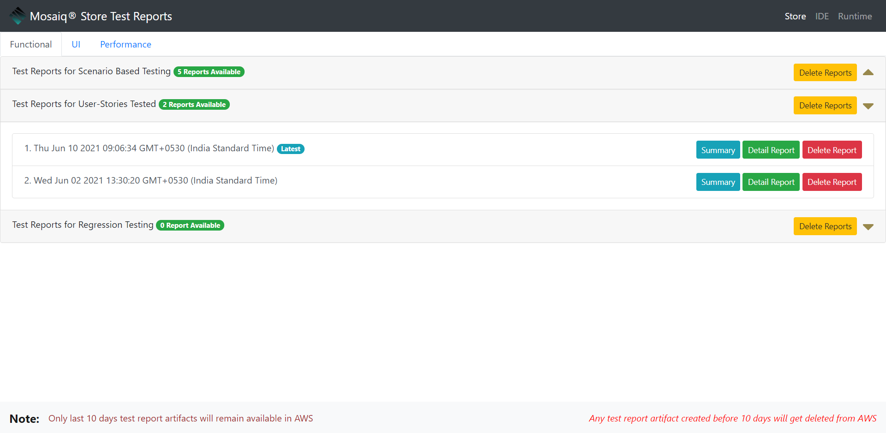

Test Automation Script Flow
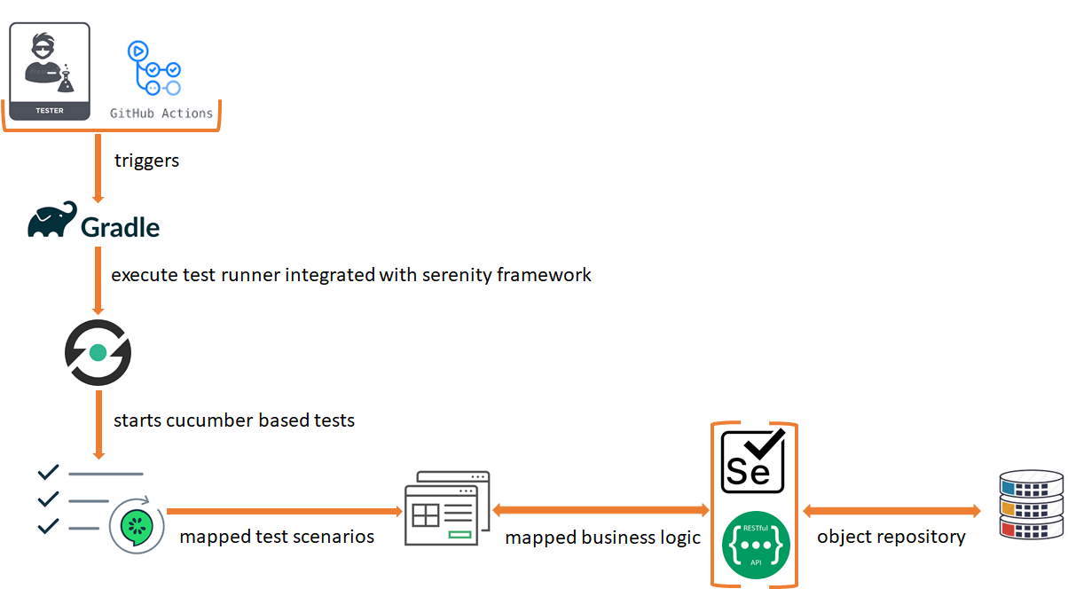

The above model explains the execution flow of functional automated test-scripts once triggered by Github Action.

Gradle is a test engine which triggers the main / test runner class from the framework. The runner class will initialize the Cucumber based feature file. Each feature file will be mapped with its relevant java class which maps defined test steps in cucumber with its relevant java function. Every mapped java class will refer business logic and object repositories.

The mapped java classes are not tightly coupled with each feature file. In fact these mapped java classes are loosely coupled and can get mapped with multiple feature files hence, making it flexible and shareable.

Same execution model is applicable to perform the frontend (functional) and rest API testing. Such approach give QA team flexibility to either develop test scripts only for frontend requirements (functional) or rest API using the same framework. Additionally, QA team can develop test scripts which can combine frontend requirements (functional) and rest API.

The test report generated will combine the results of both frontend (functional) and rest API.

Roadmap

QA team will keep extending the test coverage of Functional Automated Test-Scripts. But there are other exciting things that will be developed, Integrated and deployed.

- Development of Automated UI test-scripts using Gallen Framework
- Integration and Deployment of Automated UI test-scripts in Continuous Testing process model
- Introduction of Performance requirements
- Development of Automated Performance test-scripts using Taurus along with JMeter Framework
- Integration and Deployment of Automated Performance test-scripts in Weekly / On-Demand process model

Conclusion

QA team of Platform Services is using latest frameworks & tools to develop automated test scripts for different Test Automation Types and integrating these test scripts with the development process.

QA activities performed provides lots of learning and growth opportunities.

Key Takeaways
- Latest frameworks and tools used
- Learning and Growth opportunities
- Gain work experience in Agile based development

